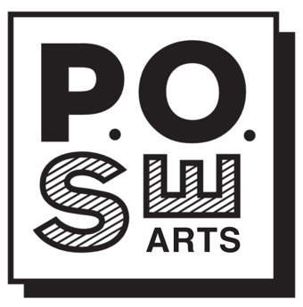 **VENUE RISK ASSESSMENT**

**POSE with City Arts Portsmouth Participants**: all artists please complete, sign and date a Risk Assessment Form for your event. It must be produced on request and may form part of any insurance claim – it will demonstrate that precautions and care were taken to reduce the risk of an incident.

**What is a risk assessment?** It is a careful examination of what could cause harm. The purpose is to consider precautionary measures in order to minimise the risk as well as identify actions in the event of an incident happening. Artists must minimise the risks (health, safety, welfare) visitors and others we come into contact with. The purpose of a risk assessment is to help artists:

- prepare for Portsmouth Open Studios Event.

- ensure a good experience for their visitors

- understand potential issues

- plan for/cope with the unexpected

**What is a risk/hazard?**

- Hazard = something with the potential to cause harm (injury, damage, loss)

- Risk = the likelihood and the severity of the harm

For example, broken glass is a hazard that could cause injury, the risk is that someone could cut themselves.

*Severity For example, if the hazard were to result in a fire, how severe will the injury/damage be?

**Low** (remote possibility of harm) **Medium** (some harm, not too serious) High (serious harm)

**Probability For example, how likely is it that a fire will occur?

- **Low** (unlikely); **Medium** (likely to occur at some time); **High** (very likely to occur).

Most risks can be reduced by good housekeeping – keeping everything in good order and following good personal and professional practice. For example, if you have smoke or other alarms, check they work. If you are part of a group, please work with all members of your group to complete a venue assessment, supplemented by individual artists assessing their own contribution to that space.

If you are in a 3rd party space please check their Public Liability Insurance. You must still provide your own.

Individual Artists please check your own insurance is appropriate and up to date.

Please keep your completed form handy. In the event of an insurance claim it is an important document. Any questions? Contact us using a form On the POSE page of City Arts Portsmouth.

Thank you

Venue (Venue brochure #/Address):

Artist Name: Signature:

Date:

